**PEAL + iPROVE-ELA**

**I**ndividualized **P**eriope**R**ative **O**pen lung **VE**ntilatory approach in **E**mergency **A**bdominal **L**aparo-tomy/scopy. A prospective multicenter randomized controlled trial

**Investigator Information Brochure PEAL + iPROVE-EAL**

1. **Dissemination of research results and sub-studies**

The Scientific Committee will appoint a Drafting Committee to draft the scientific report (s) of this research, which will be disseminated in a timely manner. It is expected that a series of secondary analyzes will be carried out. Researchers will have priority to direct this type of analysis and are encouraged to do so. Participation will be based on the contribution to the study in its two phases. The Steering Committee will take into account the scientific validity and the possible effect on the anonymity of the participating centers before the granting of any of these applications. If necessary, a prior written agreement will establish the terms of this type of collaboration. The Scientific Committee must approve the final version of all manuscripts, before submission. In case of disagreement within the Steering Committee, the head of the investigation will make a decision. Any data from the PEAL and iPROVE-EAL analysis with the incorporation of two or more study sites will be taken into account for possible secondary analyzes and will be subject to predefined rules.

***All participants in the study will be included as co-authors under the iPROVE Research Network Group.***

**Authorship for the PEAL study**

The main manuscript will be signed as iPROVE Research Network Group. All the secondary analysis, proposed by the Scientific Committee or researchers from participant hospitals, will always include the iPROVE Research Network Group.

*Each participant hospital can include one author every 3 included patients.*

**Authorship for the iPROVE-EAL study**

The authorship regulations will be specified once the final sample size has been calculated and the number of participating centers closed.

1. **eCRF for the PEAL Project.**

The data collected must be uploaded to the corresponding online CRF for final data collection.

**Register as a center in eCRF**

First of all, one must register as a participating center in the study by sending an email with the subject “Register RedCap PEAL study” in which the name and surname must be included as well as the email address that we wish to use for this service. . This email must be sent to the address [sau@clinic.cat](mailto:sau@clinic.cat)

If you do not receive a response in the following 48 hours, please contact the corresponding managers listed on the contact page that we can find on the website <http://www.iprove-network.es> in the "PEAL" section.

**Enter or modify data in eCRF**

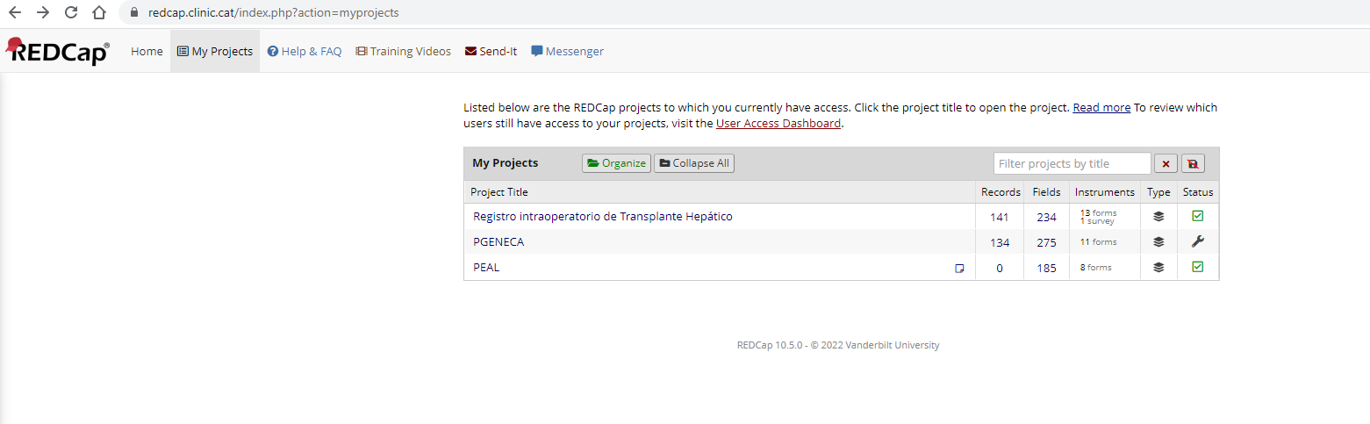P To enter the data we must enter the eCRF section of the website or directly at the address <http://www.redcap.clinic.cat>. At this point we must enter the username and password that we received when registering as a center in the eCRF.

We will enter the **“PEAL”** section and once inside we will go to the **“Add/Edit Records”** section. If we want to modify a previous record, we must mark in **“Choose an existing Patient ID”** the record number of the included patient in question. We will mark in **“Add new record”** if we want to introduce a new record.

We recommend saving the Patient ID of the patients entered in case you need to recover or modify the previous ones.

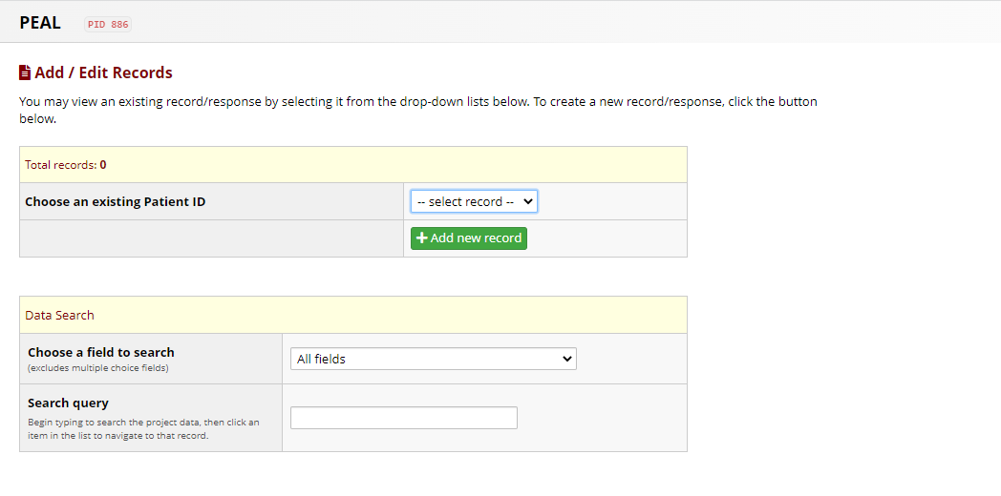

In each of the sections covered we will have at our disposal explanatory videos that will show us how data collection works and the corresponding entry in this eCRF.

1. **Study website and online randomization (iPROVE-EAL)**

In order to facilitate various procedures for researchers, the PEAL and the iPROVE-EAL trial makes available the website ([www.iprove-network.es](http://www.iprove-network.es)) from which it is possible to download patient information sheets, data collection notebooks and other documentation of interest related to the project.

The randomization of patients (iPROVE-EAL) must be done through an online application which is accessed from the website, in the section "RANDOMIZATION AREA". To enter it, the user must enter with their own password provided. Then, clicking on the link "Access to the randomization application" the website will launch a form where the center code that was provided and the patient code should be written according to the established coding. Pressing the button will execute the randomization that will be stored in the database, and the result of the group to which the patient has been assigned will appear on the screen, with the option of printing it**. IMPORTANT: Only one randomization per patient must be done through the web application.** Launching the application more than once for the same patient code can lead to errors in the subsequent analysis of the results of the data collected in your center. To avoid errors, there is a link which can be used to perform randomization tests without sending or storing results.

- The code of your center is the same user with which the private area is accessed.

- The patient code has the structure "pac", followed by a 3-digit number that represents the number of the patient recruited in your center. For example: pac-002, pac-123 ..  
On this website, you can also download paper data collection forms. However, once completed, the researcher must download the digital data collection forms, in Microsoft Word format, prepared to facilitate the entry of paper data into electronic format.

1. **Definition of complications**

|  |  |
| --- | --- |
| **Pulmonary Complications** | **PEAL + iPROVE-EAL** |
| Atelectasis | Combination of SpO2 ≤ 96% during the air test and chest radiography with lung opacification with shift of the mediastinum, hilum, or hemidiaphragm towards the affected area, and compensatory overinflation in the adjacent non-atelectatic lung |
| Hypoxemia or Mild respiratory failure | SpO2 < 92% or PaO2 < 300mmHg with FiO2 of 0.21 |
| Severe respiratory failure | Increased FiO2, increased requirement for CPAP, or the need for noninvasive or invasive ventilation |
| Weaning failure | Reintubation within the first 48h after postoperative extubation. |
| ARDS | * **Mild**: PaO2/FiO2 < 300 mmHg with CPAP ≥ 5 cmH2O y FiO2 ≥ 0.5. * **Moderate:** PaO2/FiO2 < 200 mmHg with PEEP ≥ 5 cmH2O y FiO2 ≥ 0.5. * **Severe**: PaO2/FiO2 < 100 mmHg with PEEP ≥ 5 cmH2O y FiO2 ≥ 0.5.   Acute (within one week) symptoms with bilateral pulmonary opacities |
| Pulmonary infection | Presence of a new pulmonary infiltrate and/or progression of previous pulmonary infiltrates on a chest radiograph plus at least two of the following criteria: (a) leukocytosis with > 12,000 WBC/mm3 or leukopenia with < 4000 WBC/mm3, (b) fever > 38.5°C or hypothermia < 36°C, and (c) increased secretions with purulent sputum and a positive bronchial aspirate |
| Pleural effusion | Chest radiography with the presence of costophrenic angle blunting, displacement of adjacent anatomical structures, and blunting of the hemidiaphragmatic silhouette in the supine position |
| Pneumothorax | Chest radiography with air in the pleural space with no vascular bed surrounding the visceral pleura |
| Bronchospasm | Presence of expiratory wheezing treated with bronchodilator |
| Aspiration pneumonitis | Respiratory failure after the inhalation of regurgitated gastric contents |
| Pulmonary edema | Fluid accumulation in the alveoli due to poor cardiac function diagnosed with chest radiography of lung ultrasound. |
| Pulmonary embolism | A new blood clot or thrombus within the pulmonary arterial system. |

|  |  |
| --- | --- |
| **Systemic Complications** | **PEAL + iPROVE-EAL** |
| Severe sepsis | Infectious focus identified plus organ dysfunction (defined as an increase in SOFA ≥2). |
| Septic shock | Severe sepsis with hypotension and hypoperfusion that is unresponsive to fluids. |
| Surgical site infection | The CDC defines a superficial incisional surgical site infection as one which meets the following criteria.  (1) Infection occurs within 30 days after surgery and  (2) Involves only skin and subcutaneous tissue of the incision and  (3) The patient has at least one of the following:  (a) purulent drainage from the superficial incision  (b) organisms isolated from an aseptically obtained culture of fluid or tissue from the superficial incision  (c) at least one of the following symptoms or signs of infection: pain or tenderness, localised swelling, redness or heat, and superficial incision is deliberately opened by surgeon and is culture positive or not cultured. A culture negative finding does not meet this criterion.  (d) diagnosis of an incisional surgical site infection by a surgeon or attending physician. |
| Urinary tract infection | A simplified version of the CDC recommendations defines a urinary tract infection as follows: a positive urine culture of 105 colony forming units ml1  with no more than two species of microorganisms, and with at least one of the following symptoms or signs: fever (> 38.8ºC), urgency, frequency, dysuria, suprapubic tenderness, costovertebral angle pain or tenderness with no other recognised cause. |
| Arrhythmia | ECG evidence of cardiac rhythm disturbance. |
| Myocardial infarction | Increase in serum cardiac biomarker values (preferably cardiac troponin) with at least one value above the 99th percentile upper reference limit and at least one of the following criteria:10  symptoms of ischaemia; new or presumed new significant ST segment or T wave ECG changes or new left bundle branch block; development of pathological Q waves on ECG; radiological or echocardiographic evidence of new loss of viable myocardium or new regional wall motion abnormality; identification of an intracoronary thrombus at angiography or autopsy |
| Heart failure | Cardiac index <2.5 ml/min/m2 or >2.5 when ≥5 μg/kg/min dobutamine is required. Clinical signs (hypotension, oliguria, pulmonary edema) together with NT-proBNP >13 pg/ml or echocardiographic diagnosis. |
| Acute kidney injury | AKIN scale:   * **Stage I**: Diuresis < 0,5 mg/Kg (6h) or increase in serum Cr > 0,3 mg/dl. * **Stage II**: Diuresis < 0,5 mg/Kg (12h) or basal Cr x 2 mg/dL. * **Stage III**: Diuresis < 0,3 mg/Kg (24h) o anuria (12h) or basal Cr x 3 mg/dL, or Cr > 4 mg/dL or renal replacement therapy. |
| Delirium | Positive Confusion Assessment Method for the Intensive Care Unit (CAM-ICU) (see information brochure) |
| Paralytic ileus | Failure to tolerate solid food or defecate for three or more days after surgery |
| Postoperative hemorraghe | blood loss within 72 h after the start of surgery which result in transfusion of blood or a drop in hemoglobin > 7gr/dL |
| Anastomotic breakdown | Leak of luminal contents from a surgical connection between two hollow viscera. The luminal contents may  emerge either through the wound or at the drain site, or they may collect near the anastomosis, causing fever, abscess,  septicemia, metabolic disturbance and/or multiple organ failure. The escape of luminal contents from the site of the  anastomosis into an adjacent localized area, detected by imaging, in the absence of clinical symptoms and signs should  be recorded as a subclinical leak. |

1. **Scales and calculations**

**ASA physical status classification system**

|  |  |
| --- | --- |
| **ASA I** | **A normal healthy patient.** Healthy, non-smoking, no or minimal alcohol use |
| **ASA II** | **A patient with mild systemic disease.** Only mild diseases without substantive functional limitations. Examples include (but not limited to): current smoker, social alcohol drinker, pregnancy, obesity (30 < BMI < 40), well-controlled DM/HTN, mild lung disease |
| **ASA III** | **A patient with severe systemic disease.** Substantive functional limitations; One or more moderate to severe diseases. Examples include (but not limited to): poorly controlled DM or HTN, COPD, morbid obesity (BMI ≥40), active hepatitis, alcohol dependence or abuse, implanted pacemaker, moderate reduction of ejection fraction, ESRD undergoing regularly scheduled dialysis, premature infant PCA < 60 weeks, history (>3 months) of MI, CVA, TIA, or CAD/stents. |
| **ASA IV** | **A patient with severe systemic disease that is a constant threat to his life.** Examples include (but not limited to): recent ( < 3 months) MI, CVA, TIA, or CAD/stents, ongoing cardiac ischemia or severe valve dysfunction, severe reduction of ejection fraction, sepsis, DIC, ARD or ESRD not undergoing regularly scheduled dialysis |

**Body mass index (BMI):** Kg/m2

**Predicted body weight (PBW):**

men: PBW (kg) = 50 + 0.91 (height in cm-152)

women: PBW (kg) = 45.5 + 0.91 (height in cm-152)

|  |  |  |  |  |  |  |
| --- | --- | --- | --- | --- | --- | --- |
| **8 ml/kg PBW in men** | | |  | **8 ml/kg PBW in women** | | |
| 162 cm  470 ml | 164 cm  485 ml | 166 cm  500 ml | 153 cm  370 ml | 155 cm  385 ml | 157 cm  400 ml |
| 168 cm  515 ml | 170 cm  530 ml | 171 cm  535 ml | 159 cm  415 ml | 160 cm  420 ml | 161 cm  425 ml |
| 172 cm  540 ml | 173 cm  550 ml | 174 cm  560 ml | 162 cm  435 ml | 163 cm  440 ml | 164 cm  450 ml |
| 175 cm  565 ml | 176 cm  570 ml | 177 cm  580 ml | 165 cm  455 ml | 166 cm  465 ml | 167 cm  470 ml |
| 178 cm  585 ml | 179 cm  595 ml | 180 cm  600 ml | 168 cm  475 ml | 169 cm  485 ml | 170 cm  490 ml |
| 182 cm  615 ml | 184 cm  630 ml | 186 cm  645 ml | 171 cm  500 ml | 172 cm  505 ml | 174 cm  520 ml |
| 188 cm  660ml | 190 cm  670 ml | 192 cm  685 ml | 176 cm  530 ml | 178 cm  550 ml | 180 cm  565 ml |

**Visual Analog Scale (VAS)**

The VAS scale allows to measure the pain intensity that the patient describes with the maximum reproducibility among the observers. It consists of a horizontal line of 10 centimeters, at the ends of which are the extreme expressions of a symptom. On the left is the absence of pain or less intensity. The patient is asked to mark the point indicating the intensity on the line and it is measured with a millimeter ruler. The intensity is expressed in centimeters or millimeters.

**Charlson comorbidity index**

|  |  |
| --- | --- |
| **Clinical condition** | **Weight** |
| - Myocardial infarct, Congestive cardiac insufficiency, peripheral vascular disease, cerebrovascular disease.  - Dementia  - COPD  - Ulcers  - Conjunctive tissue disease  - Cirrhosis or chronic disease of the liver  - Diabetes | **1** |
| - Hemiplegia  - Moderate or severe kidney disease  - Diabetes with organ complication  - Tumor/Leukemia/Lymphoma | **2** |
| - Moderate or severe liver disease | **3** |
| - Malignant tumor, metastasis, AIDS | **6** |

**Apfel score for PONV**

|  |  |  |  |
| --- | --- | --- | --- |
| **Risk factors** | **Points** | **Risk factors** | **Points** |
| **Female gender** | 1 | **Postoperative Opioids** | 1 |
| **Non-smoker** | 1 | **Sum=** | 0………4 |
| **History PONV** | 1 |  |  |

**SOFA (Sequential Organ Failure Assessment) SCORE**

|  |  |  |  |  |  |
| --- | --- | --- | --- | --- | --- |
| **System** |  | | | | |
|  | **0** | **1** | **2** | **3** | **4** |
| **Cardiovascular** | MAP > 70 mmHg | MAP < 70 mmHg | Dopamine≤5 μg/kg/min or dobutamine (any dose) | Dopamine>5 or epinephrine≤0.1 or norepinephrine ≤0.1 | Dopamine>5 or epinephrine >0.1 or norepinephrine >0.1 |
| **Respiratory** (PaO2/FiO2) | >400 | 301-400 | 201-300 | 101-200 | ≤ 100 |
| **Hepatic** (bilirrubin,μmol/l mg/dl | ≤ 20  <1.2 | 20-32  1.1-1.9 | 33-101  2.0-5.9 | 102-204  6.0-11.9 | >204  >12.0 |
| **Kidney** (creatinine**,** μmol/l)  mg/dl | ≤ 110  <1.2 | 110-170  1.2-1.9 | 171-299  2.0-3.4 | 300-440;  3.5-4.9;  or  urine output ≤500 ml/d | >440;  >5.0;  or  urine output <200 ml/d |
| **Coagulation** (platelets, x 103/microL) | >150 | ≤150 | ≤100 | ≤50 | ≤20 |
| **SNC** (Glasgow Coma Scale) | 15 | 13-14 | 10-12 | 6-9 | <6 |

**ARISCAT Score**

|  |  |  |  |
| --- | --- | --- | --- |
| **Age** | ≤ 50 | | 0 |
| 51-80 | | 3 |
| ≥ 80 | | 16 |
| Preoperative SpO2 | ≥ 96 | | 0 |
| 91- 95 | | 8 |
| ≥ 90 | | 24 |
| Respiratory infection (last month) |  | | 17 |
| Preoperative hemoglobin (≥ 10 g/dl) |  | | 11 |
| Surgical incision | | Peripherical | 0 |
| **Abdominal** | 15 |
| Intrathoracic | 24 |
| Duration of surgery (h) | ≤ 2 | | 0 |
| > 2 a 3 | | 16 |
| > 3 | | 23 |
| **Emergency surgery** |  | | 8 |

**Richmond Agitation Sedation Scale (RASS)**

|  |  |  |
| --- | --- | --- |
| **Score** | **Term** | **Description** |
| **+4** | **Combative** | Overtly combative or violent; immediate danger for the staff |
| **+3** | **Very agitated** | Pulls on or removes tube(s) or catheter(s) or has aggressive behavior towards staff |
| **+2** | **Agited** | Frequent nonpurposeful movement or patient–ventilator dyssynchrony |
| **+1** | **Restless** | Anxious or apprehensive movements but not aggressive or vigorous |
| **0** | **Alert and calm** | Spontaneously pays attention to caregiver |
| **-1** | **Drowsy** | Not fully alert, but has sustained (more than 10 seconds) awakening, with eye contact, to voice |
| **-2** | **Light sedation** | Briefly (less than 10 seconds) awakens with eye contact to voice |
| **-3** | **Moderate sedation** | Any movement (but no eye contact) to voice |
| **-4** | **Deep sedation** | No response to voice, but any movement to physical stimulation |
| **-5** | **Unarousable** | No response to voice or physical stimulation |

**CAM-ICU scale**

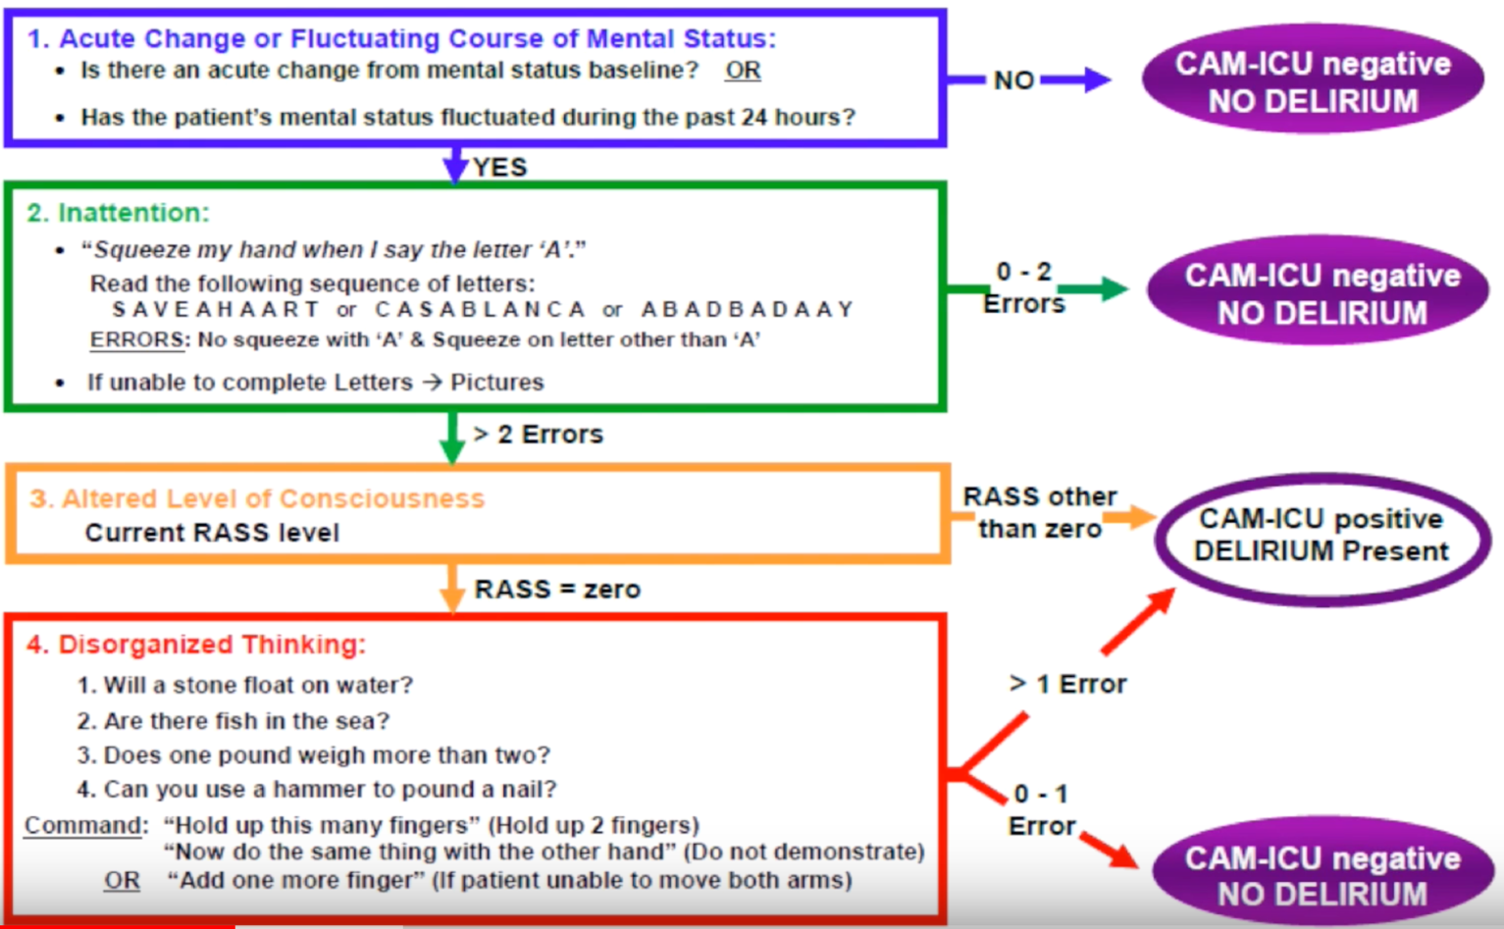

**Clinical Fraily Scale**

|  |  |  |
| --- | --- | --- |
| **CLINCAL FRAILTY SCALE** | | |
| Very fit | Robust, active, energetic, motivated. Exercise regularly. |  |
| Well | No active disease symptoms. Exercise or very active occasionally. |  |
| Managing well | Well controlled medical problems. Not regularly active (walking). |  |
| Vulnerable | Symptoms limit activities, but not dependent on others for daily help. |  |
| Mildly frail | Evident slowing and need help in instrumental activities of daily living (controlling medication, finances, transportation, heavy housework). Typically impairs shopping, walking outside alone, meal preparation and housework. |  |
| Moderately frail | Need help with all outside activities and housekeeping. Often have problems with stairs and need help with bathing and getting dressed. |  |
| Severely frail | Completely dependent for personal care, any physical or cognitive activity. Stable, not at high risk of dying within 6 months. |  |
| Very severely frail | Completely dependent, approaching the end of life.  Typically, they could not recover from a minor illness. |  |
| Terminally ill | Approaching the end of life. Life expectancy < 6 months. |  |